**Database System**

**Quiz 1**

**Fall 2022**

202135574 전시현

*\* Please note that all answers should be written in* ***English****.* ***No cheating*** *is allowed. (It will be* ***F*** *if found any.) Total grade is 100 points.*

**1. [30pt] Write a term for each of the following descriptions.**

(a) [5pt] It contains information about a particular organization. It includes collection of inter-related data, set of programs to access the data and an environment that is convenient and efficient to use data

Database

(b) [5pt] It models an organization as a collection of entities and their relationships. It facilitates database design by allowing specification of an enterprise schema that represents the overall logical structure of a database.

E R model

(c) [10pt] It is a kind of language that define the schema and storage stored in a data dictionary. Write the entire word, not the abbreviation. List at least three commands in this.

Data Definition Language (DDL)

(d) [5pt] When we define the table, it guards against accidental damage to the database. It ensures authorized changes to database do not result in a loss of data consistency.

Integrity constraints

(e) [5pt] It is a key to link two tables together. The table containing “this” is called the child table, and it refers parent table.

**Foreign key**

**2. [10pt] Fill out the blank of the following statement**

|  |
| --- |
| In the formal relational model terminology, a row is called a (____a____), a column  header is called (____b____), and the table is called (____c____). The data type  describing the types of values that can appear in each column is represented by (____d____) of possible values. Examples of (____d____) are as follows. The set of seven-digit phone numbers valid within a particular area code in the United States. |



(a) __________________tuple_________________________

(b) _________________attribute________________________

(c) _________________relation__________________________

(d) ___________________domain________________________

**3. [15pt] Consider the employee database, where the primary keys are underlined. Give an expression in SQL for each of the following queries.**

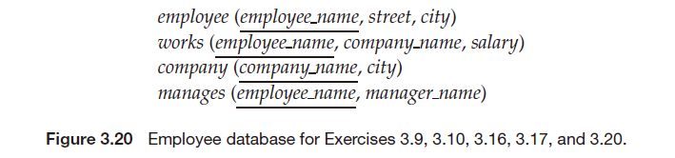

(a) [5pt] Find the names of all employees who work for “First Bank Corporation”.

Select employee_name from works where company_name = “First Bank Corporation”

(b) [5pt] Give all employees of “First Bank Corporation” a 10 percent raise.

**Update works set salary = salary * 1.1 where company_name = “**First Bank Corporation**”**

(c) [5pt] Delete all tuples in the works relation for employees of “Small Bank Corporation”.

delete from works where company_name = “Small Bank Corporation”

**4. [15pt] Considering the following query, write a relational algebra expression that computes the result.**

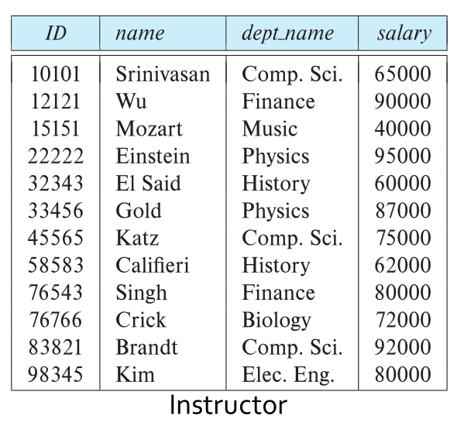 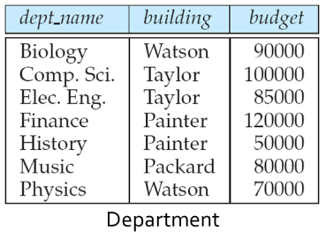 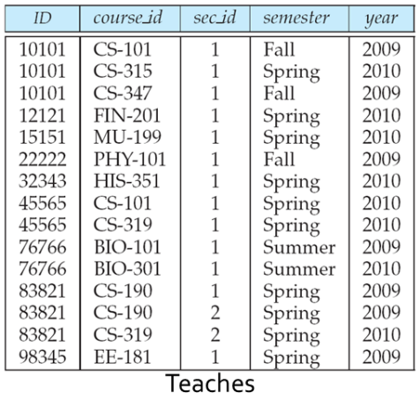

(a) [5pt] Find the instructors in Physics with a salary greater $90,000

**δ(dept_name = “Physics” ∩ salary>90000)(instructor)**

(b) [5pt] Find the names of all instructors in the Physics department.

∏name(**δ**(dept_name = “Physics”) (department))

(c) [5pt] Find information about courses taught by instructors in the Physics department.

(Hint: Use natural join )

**δ**(dept_name = “Physics”) (instructorinstructor.ID = teaches.IDTeaches)

**5. [20pt] Draw E-R diagram to represent the following example. Both instructor and student have unique ID and name.**

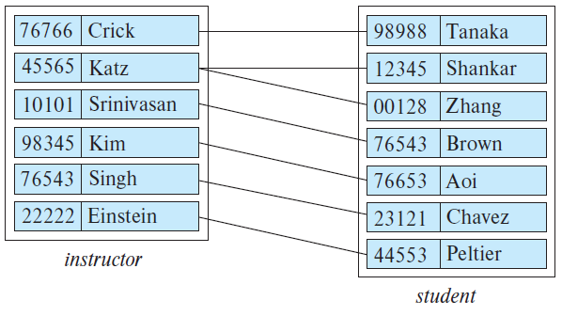 

Figure. 4-1 Figure. 4-2

(a) [10pt] Draw E-R diagram of Figure 4-1.

|  |
| --- |
|  |

(b) [10pt] Draw E-R diagram of Figure 4-2.

|  |
| --- |
|  |

**6. [10pt] Consider a database that includes the entity sets *student*, *course*, and *section* from the university schema and that *additionally records the marks* that students receive in different exams of different sections.**

**Construct an E-R diagram using each blocks that models exams as entities and uses a ternary relationship as part of the design.**

